Disjoint Set Union

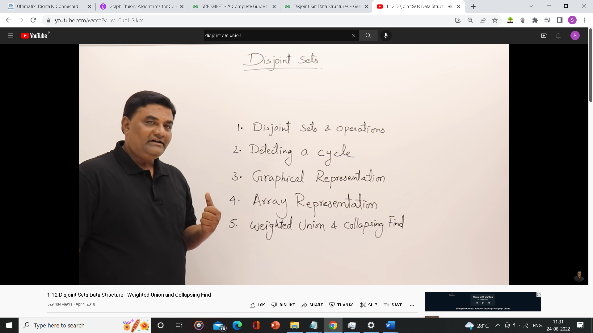

Disjoint sets are sets that have nothing in common

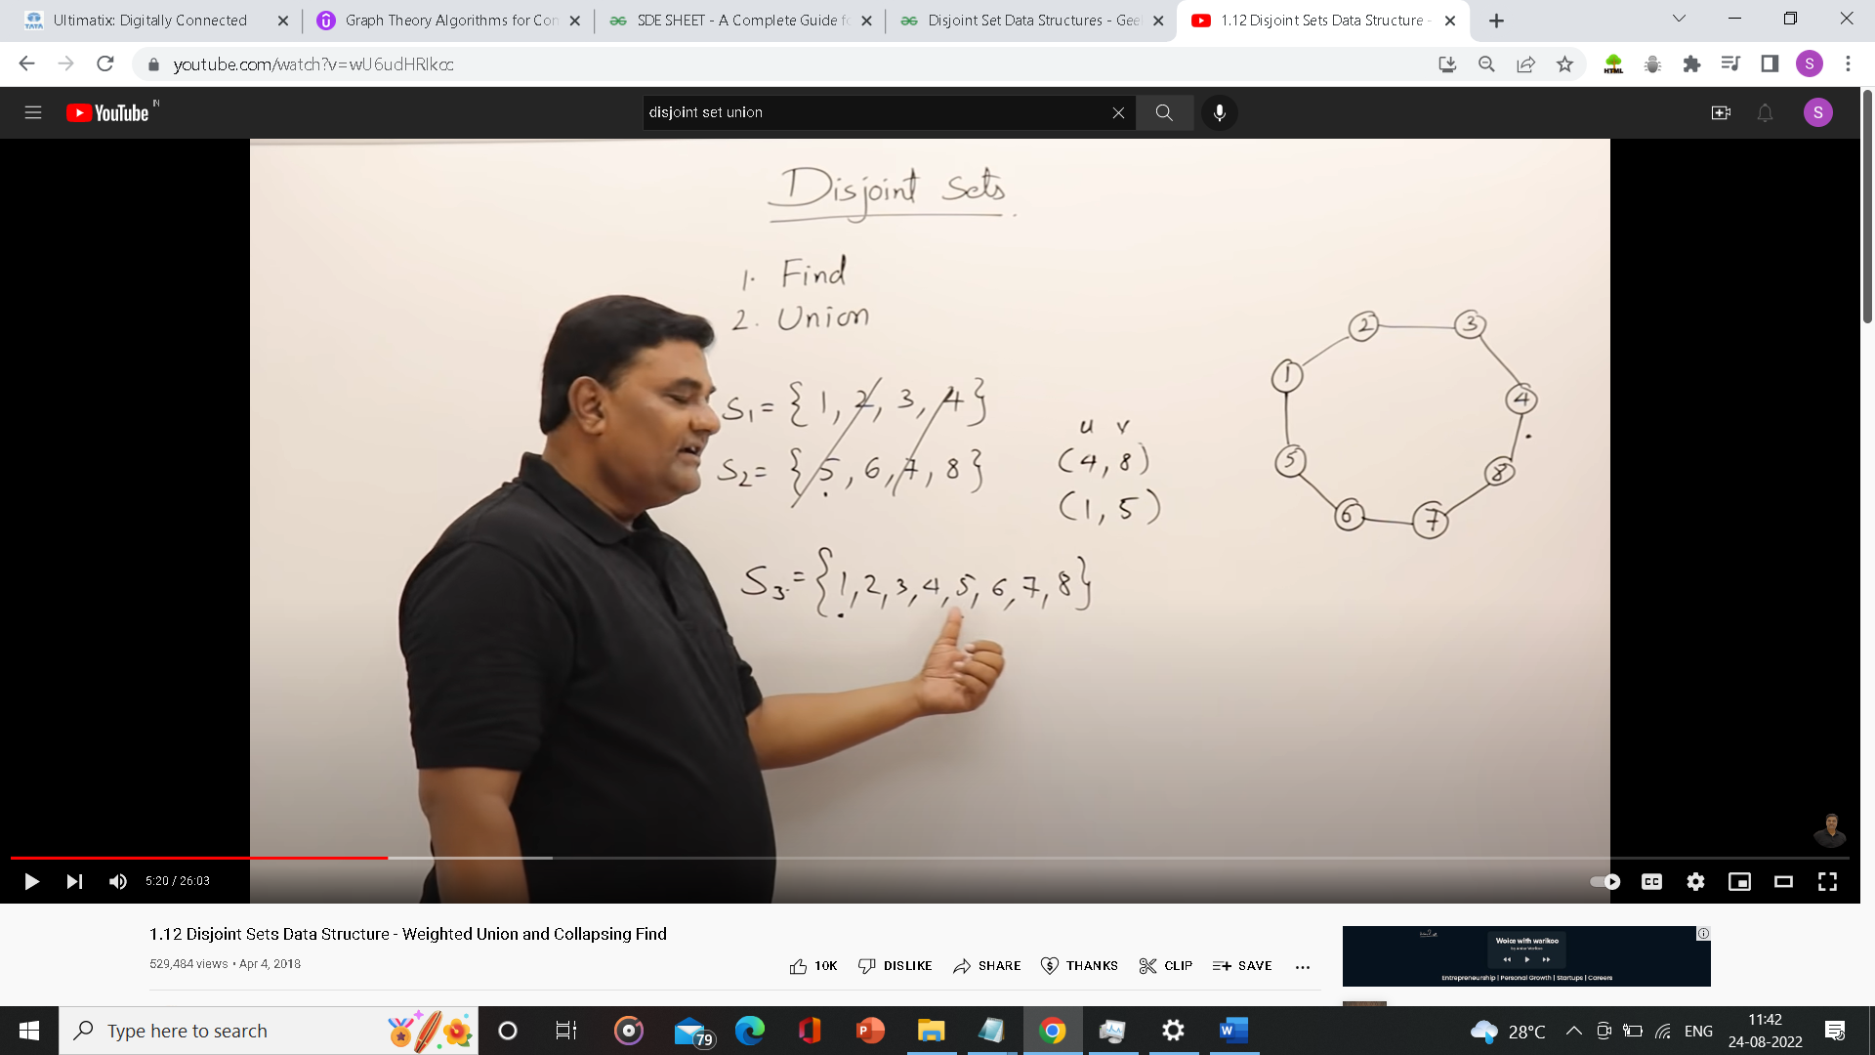

Union of (4,8) leads to merging of S1 and S2 as both are from different sets. When Union is performed on two points in same set it leads to formation of cycle.

**Example using a graph**

Going through all the edge by weights and forming disjoint set

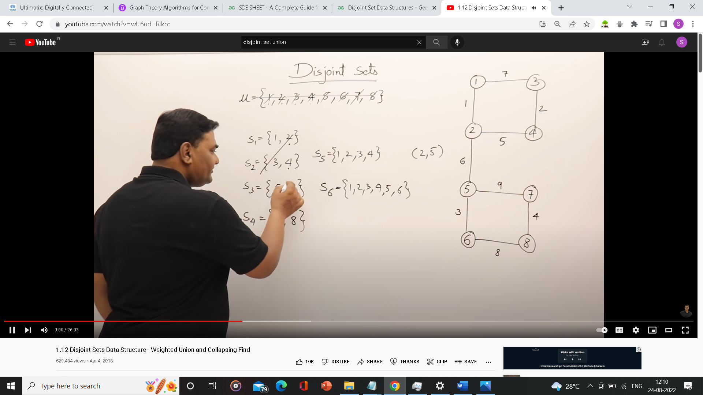

Now if you see if we perform Union of (1,3) it will lead to formation of cycle as both belong to same set.

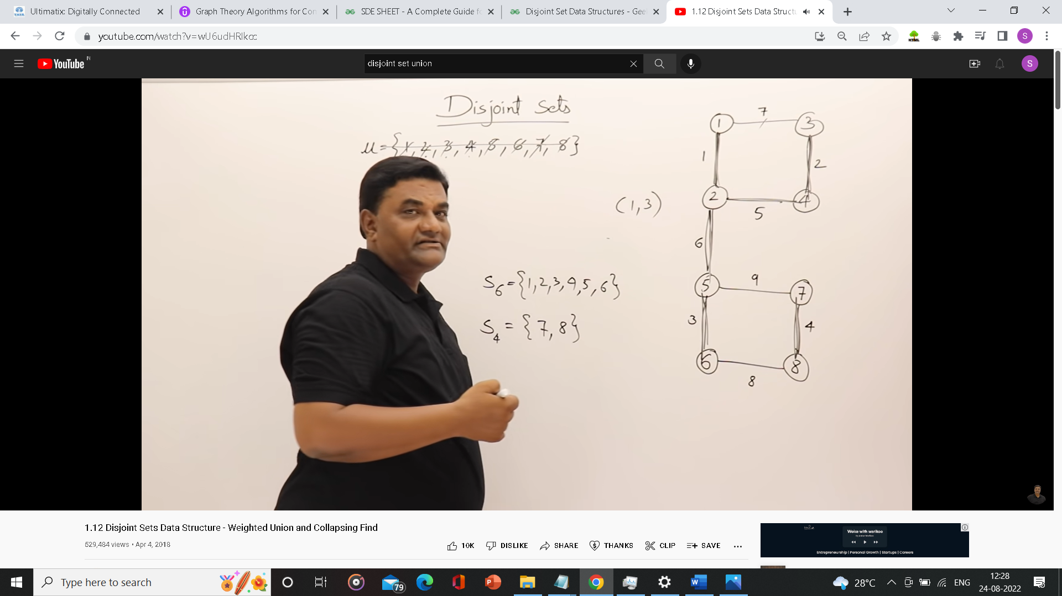

Disjoint Set using Array

